Stakeholder Analysis
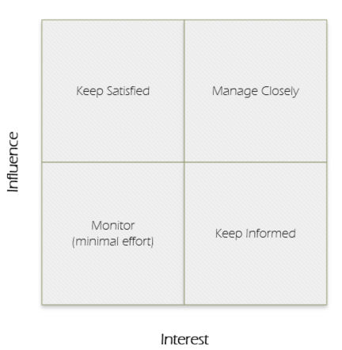
It is important to measure and understand the level of stakeholder influence (sometimes called “power”), interest, and engagement throughout the project. The level of stakeholder “interest” measures their level of concern over project outcomes. The level of stakeholder “influence” measures their level of authority over the project

Stakeholders can be classified as:
Low interest/high influence = keep satisfied
Low interest/low influence = monitor
High interest/high influence = manage closely
High interest/low influence = keep informed

Stakeholder engagement levels can be categorized as the following:
- Unaware
- Resistant
- Neutral
- Supportive
- Leader
It is important that corrective action is taken if a stakeholder with high interest and high power is resistant or unaware.
Copy and paste the list of stakeholders from your Project Charter and insert them below. For each individual or group, categorize them accordingly.
Key Stakeholders | Role to the project | Interest level | Influence level | Engagement level
[insert name and title] | Project Sponsor | Choose an item. | Choose an item. | Choose an item.
[insert name and title] | Project Owner | Choose an item. | Choose an item. | Choose an item.
[insert name and title] | Project Manager | Choose an item. | Choose an item. | Choose an item.
 |  | Choose an item. | Choose an item. | Choose an item.
 |  | Choose an item. | Choose an item. | Choose an item.
 |  | Choose an item. | Choose an item. | Choose an item.
 |  | Choose an item. | Choose an item. | Choose an item.
 |  | Choose an item. | Choose an item. | Choose an item.
 |  | Choose an item. | Choose an item. | Choose an item.

