Spaghetti Diagram
UTM Project Management Office
utm.utoronto.ca/pmo
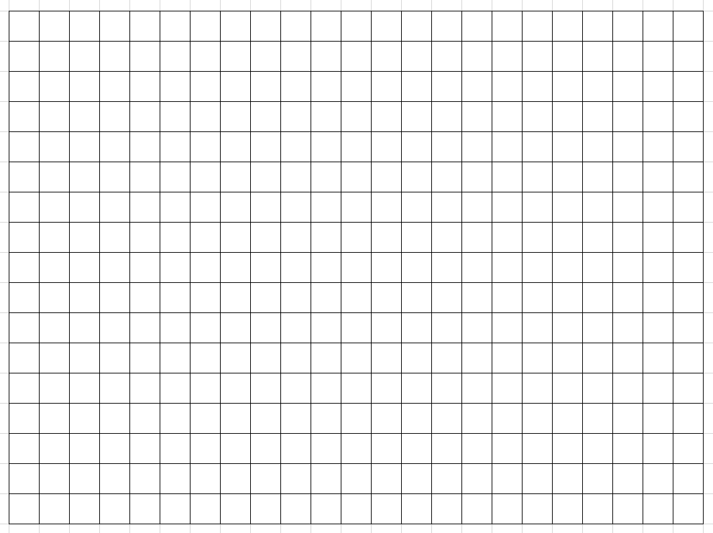
About
The Spaghetti Diagram is a visual representation of a specific process or workflow that illustrates the movement and interactions of people, equipment, or materials within a process.
It reveals patterns, bottlenecks, and inefficiencies in the workflow and can help teams focus their efforts on changes that will have the most significant impact on efficiency and quality.
It provides a tangible representation of data, and can even be used to illustrate interactions between cross-functional teams!
Tips
- Plot the process
- Invite the team to draw the actual flow (not perceived)
- One line represents one trip or movement.

