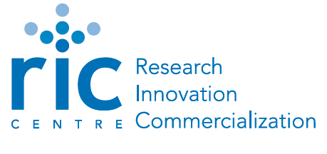
Startup Weekend Peel
October 19 – 21, 2012
Background

The Mission

Startup Weekend is a global grassroots movement of active and empowered entrepreneurs who are learning the basics of founding startups and launching successful ventures. The non-profit organization is headquartered out of Seattle, Washington but Startup Weekend organizers and facilitators can be found in over 150 cities around the world. From Mongolia to South Africa to Canada to Brazil, people around the globe are coming together for weekend long workshops to pitch ideas, form teams, and start companies.

The Event
All Startup Weekend events follow the same basic model: anyone is welcome to pitch their startup idea and receive feedback from their peers. Teams organically form around the top ideas (as determined by popular vote) and then it’s a 54 hour frenzy of business model creation, coding, designing, and market validation. The weekends culminate with presentations in front of local entrepreneurial leaders with another opportunity for critical feedback. Whether entrepreneurs found companies, find a cofounder, meet someone new, or learn a skill far outside their usual 9-to-5, everyone is guaranteed to leave the event better prepared to navigate the chaotic but fun world of startups.
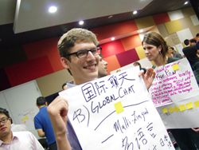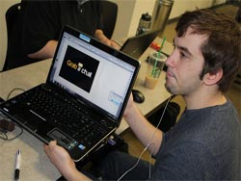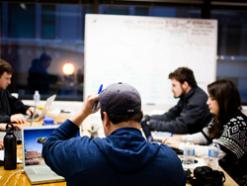

The Value
First and foremost, Startup Weekends are about learning through the act of creating. Participants don’t just listen to theory, but build their own and truly put it to the test while collaborating with like-minded, passionate individuals from a wide variety of backgrounds and points of view. On top of that, Startup Weekenders receive invaluable one-on-one time with the movers and shakers within the community, as local tech and startup leaders take part in Startup Weekends as coaches and judges.
It’s important to remember that it’s not just about the idea – it’s about the team. Startup Weekend attracts each community’s best makers and do-ers, and by spending a weekend working to build scalable companies that solve real-world problems, our participants build long-lasting relationships and may even walk away with a job or an investor. In fact, over 36% of Startup Weekend startups are still going strong after 3 months, and roughly 80% of participants plan on continuing working with their team or startup after the weekend. Startup Weekend is hands down the best way to find someone you can actually launch a startup with! But possibly most valuable of all, is that not only will participants be integrating with their local community, but they will be joining a global community of over 30,000 Startup Weekend alumni with a common mission: to change the world.
Agenda:
Beginning with open-mic pitches on Friday, attendees bring their best ideas and inspire others to join their team. Over Saturday and Sunday teams focus on customer development, validating their ideas, practicing LEAN Startup Methodologies and building a minimal viable product. On Sunday evening teams demo their prototypes and receive valuable feedback from a panel of experts and one team gets crowned the winner.
In Peel Region, we feel this is a great way to encourage great ideas and support entrepreneurship!

