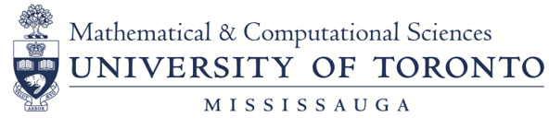

1st Place at the 2018 Toronto Cyber Security Challenge | Darren Terrance Hobin  Darshan Mahendra Mehta  Nimesha Rukshan Jayawardena  Rajdeep Nanua
1st Place Prize for the “Best Use of the Blockchain” in UofTHack | Abdul Wasay Mehar  Vaishvik Maisuria
Anne Holden Memorial Scholarship | Maha Kesibi  Shubham Sharma
Award for Excellence in Teaching by a Junior Member of the UTM MCS Research Community | Remus Radu  Timothy Yusun
Dean’s Excellence Award in Writing | Maria Geneva Roselle Marino Liwag
Dorris Geddes Scholarship | David Zhiyang Cui
Elizabeth and William Star Award | Dariya Darvin
June Scott Award | Nimesha Rukshan Jayawardena
NSERC Undergraduate Student Research Award (USRA) | Eric Joseph Ramalheiro  Jarvis Kennedy  Maria Geneva Roselle Marino Liwag
Olga Fraser Award | Yi Wai Kwok
Outstanding Program Performance | Chun Man Clement Wan
Peter Fantham Memorial Scholarship | Jarvis Kennedy
Tom Hull Scholarship | Jacob Atzori
Trenwith Award | Justin Richard Leung
2018 MCS AWARDS RECEPTION
Thursday, October 18, 2018
Deerfield Hall, DH-3050

