May 10, 2022, last update December 21, 2022
Xin Zhao | Core Facility Technician
Life Sciences Core Facilities | Office of the Vice-Principal, Research
University of Toronto Mississauga
Email: xin.zhao@utoronto.ca |Office Phone: 905 569 4270

Free Shipping Program for Eurofins Genomics Sanger Sequencing and Oligos Service

Overview
- Eurofins Genomics LLC provides a free shipping drop box at UTM for Researchers using Eurofins Genomics Sanger sequencing and Oligos service. The program is under the care of Life Sciences Core Facilities.
- Special discount price for Sanger sequencing order:
- Tube Sequencing: $3.25/reaction
- Plate Sequencing: $3.00/reaction. Minimum 24 samples
- Special discount price for Oligos order:
- Oligos in Tubes: 10nmol scale, $0.16cents/base, up to 70 bases long
- Oligos in Tubes: 25nmol scale, $0.17 cents/base
- Oligos in Tubes:50nmol scale, $0.36 cents/base, up to 90 bases long
- Oligos in Tubes:250nmol scale: $0.60 cents/base, up to 125 bases long
- Special discount price for projects: Further discount may apply by contacting Eurofins Genomics business manager Mufaddal Culter.
- Getting sequencing results or receiving Oligos within 36 to 48 hours.
- The drop box is located outside of room DV3092K, sequencing samples will be shipped out collectively once per week using prepaid UPS envelop through Life Science Core facilities.
- Oligos orders will be delivered to Life Science Core Facilities at no shipping cost.
- Eurofins Genomics contact information:
Mufaddal Cutler
Business Manager
Mobile: 647 234 5152
Email: MufaddalCutler@eurofinsus.com
- Life Sciences Core Facilities Contact
Xin Zhao
Core Facility Technician
Office Phone: 905 569 4270
Email: xin.zhao@utoronto.ca
.

Operation Procedure
Creating an account with Eurofins Genomics
- Create an account through the link below, each lab creates one account for all lab members. If you are current Eurofins user and already have an account, go to next step.
https://www.eurofinsgenomics.com/en/checkout/login-register.aspx?nodeId=1086
- Follow instructions below to provide account information to business manager to get discount prices for your lab.
- Send an email to Mufaddal, Subject: UTM-Sequencing & Oligos
- Provide account information in the email:
- Login user name
- Account number
- PI name
- Lab room number
- Lab manager (or point of contact) name and phone number
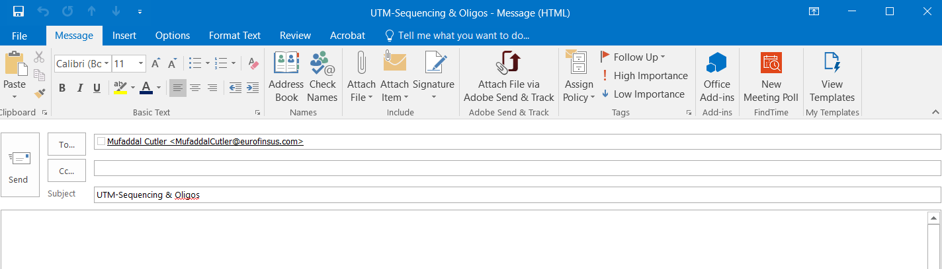
- Allow 48 hours to activate your account after account information being sent out. An agreement number for discounted prices has been added to your account when it is activated and discounted prices will apply to each orders automatically.

Submitting Sanger Sequencing Samples
- Get free barcodes and blue seal bags for your lab from Xin Zhao to pack samples.
- Place orders online through your Eurofins account. For requirements of sample concentration and volume and primers, check the Sample Submission Guidelines or follow the instructions on Eurofins website.
- Tape one barcode per tube in accordance with your order form, pack samples into the blue seal bag (or any small plastic bag) with a copy of completed order form and write down shipping address on the bag:

Sequencing Lab
(502)302-6320
Eurofins Genomics-SEQ LAB
12701 Plantside Drive
LOUISVILLE KY 40299-6388
United States
- There is no need to use barcodes if you use strip PCR tubes for packing samples, please see detailed instruction on Eurofins website.
- Drop sample bag to the drop box located outside of DV3092K before 4pm on Monday and Wednesday. Samples will be collectively sent to UTM Shipping/Receiving for UPS delivery. It is guaranteed that samples will be sent out on Tuesday and Thursday from UTM Shipping /Receiving.

Ordering Oligos
- Place order through your Eurofins account.
- Oligos will be shipped to Life Sciences Core Facility at UTM within 36-48 hours.
- Users will get email notification for picking up Oligos in room DV3092E.

Troubleshooting Problems with Account, Billing, Sample Results and Delivery
- Account and Billing Issues
Contact Mufaddal by phone or email.
- Unsatisfied Results
- Email to GenomicsSupport@eurofins.com and CC to Mufaddal Cutler MufaddalCutler@eurofinsus.com with your order number. The response will come within 1-2 days.
- Or call toll free number 1-800-688-2248 Option# 2 from Monday to Friday 9:00am to 5:00 pm eastern time.

- Delayed Results
- For Sequencing orders, send email to xin.zhao@utoronto.ca with your order number.
- For Oligo orders, email to GenomicsSupport@eurofins.com and CC to Mufaddal Cutler MufaddalCutler@eurofinsus.com with your order number.

