WDI Assessment Overview: MAT202

For this assessment overview, a total of twenty-four (24) assignments were reviewed from 12 different students – two (2) level A students, four (4) level B students, four (4) level C students, and two (2) level D students. In order to assess whether there was an improvement in student writing, two different assignments were reviewed for each student – the very first writing assignment that students submitted as well as their final portfolios, which gave the students the chance to improve their work based on their TA’s feedback. Students’ writing was assessed with respect to sentence completeness, grammatical correctness, clarity and ease of understanding, effective use of transitions and signposting, and overall appropriateness of language for writing relatively formally to second year students.

Each of the students whose assignments were reviewed demonstrated an improvement in at least one of the writing criteria assessed, with the majority of students demonstrating improvement in three (3) or more categories. While the most improvement is seen in the level B, level C, and level D students, these results are indicative that all students likely benefit from the writing assignments in this course, despite of their level of achievement.

Complete Sentences

This was the category that students improved the most. Out of the twelve (12) students assessed, nine (9) showed an improvement of at least one level in this category. This category also presented the most drastic change when comparing the first assignment with the last assignment that was submitted. Perhaps because students did not quite know what a writing assignment consisted of or what was expected of them, a lot of students simply presented their mathematical reasoning without offering much discussion (see Figure 1).

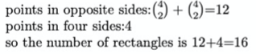

Figure 1 - One student’s work that was particularly devoid of complete sentences
Likely armed with a better understanding, all students assessed delivered final portfolios that presented their reasoning in complete sentences with each final assignment scoring a level of at least 3 in this category.

Grammatical Correctness

In my opinion, this was one of the categories students struggled with the most in both versions of the assignments, perhaps due to a language barrier or limited practice in expressing mathematical thinking in a detailed, written format. Three types of grammatical errors were commonly seen: run-on sentences, improper verb conjugation, and incorrect use of plural form. Each of these common errors are further discussed below:
- Run-on sentences – most students did not seem to know how to properly use punctuation (commas and periods) to effectively organize their thoughts and share their ideas (see Figure 2).

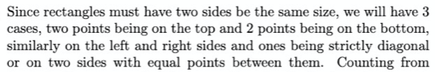

Figure 2 - Example of a run-on sentence in a student's first assignment.

This is a point that is important to discuss as improper use of punctuation severely affects sentence clarity and may result in the reader feeling confused and unsure of what is being discussed by the student.
- Improper verb conjugation – as I read through the submissions, I noticed that students also struggled with conjugating verbs correctly. For example, one student repeatedly wrote “vertex must be chose” while another student wrote “it cannot forms”. While these are small mistakes that can be easily overlooked, they do distract from the mathematical argument being made.
- Incorrect use of plural form – one other instance of small mistakes that added up to take away from the main argument came as a result of the incorrect use of plural form. Expressions that incorrectly used the plural, such as “each sides”, “vertexes”, and “form a quadrilaterals”, were heavily present in several assignments. Perhaps because such mistakes are so minor, most were not really addressed in the final submission.

Overall, I did see an improvement between the first and final assignments; however, a lot of these issues were still present in the final portfolios, especially run-on sentences.

Sentence Clarity

Just like with the category of “Grammatical Correctness”, students also seemed to have faced some challenges regarding sentence clarity, which is again likely due to a language barrier or limited practice in expressing mathematical thinking in a detailed, written format. I found myself having to read certain sentences three or four times before I was able to understand what a student was trying to convey (see Figure 3).

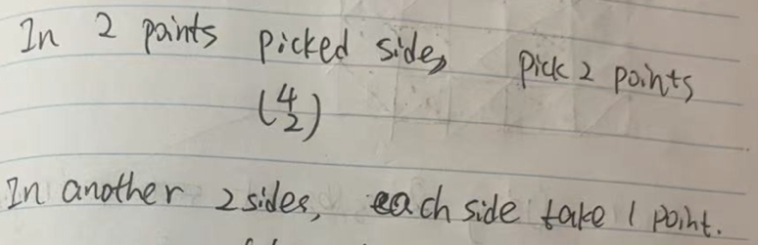

Figure 3 - Example of sentences lacking clarity.

I think that this issue of lack of clarity stemmed in part from a lack of detail as well. As mentioned previously, in the first assignment, students focused more on presenting mathematical formulas rather than explaining their reasoning in words. Again, this might have been due to a misunderstanding of expectations as most students did show improvement in this category in the final portfolio.

Transition Expressions and Signposting

Students did quite well in this category, with most students using at least one transition expression to link their reasoning and show the logical relationship between their arguments in both assignments. In the first assignment, students used transition words, such as “hence”, “therefore”, and “thus”, to indicate cause and effect almost exclusively. In the final assignment, I saw a more varied use of transition words. Expressions such as “first”, “next”, and “finally” were used to indicate sequence and order; “for example” and “for instance” were used to illustrate thinking; and “also”, “additionally”, and “furthermore” were used to present additional evidence and support to their reasoning. Such an improvement was reflected in the rubric with eight (8) students scoring at least one level higher in final portfolio than they did in the first assignment.

Language Level

While students’ writing was not perfect, I do believe that most students’ language is at an appropriate level for writing relatively formally to second year students. Ignoring the grammar mistakes and syntax issues that were discussed above, students have demonstrated the ability to successfully communicate mathematical thinking, especially in the final portfolios. As a matter of fact, six (6) of the twelve (12) students assess scored a maximum level of 4 on their final portfolio while the remaining six (6) students scored a level 3, which indicates students did quite well in this category as well.

Additional Comments/Observations

Reviewing both versions of the assignment, there was one point in particular that I noticed regarding the students’ written explanations that might be of value to mention: incomplete explanations with a lack of justification/evidence. Most students started their explanations right and also got to the correct conclusion; however, their reasoning was incomplete and required the reader to “fill-in-the-blanks”. This is a point worth noting especially if one of the goals of the writing assignments is to prepare students to write for an audience with a limited background in mathematics. In addition, I also noticed that not many students supported their mathematical claims and computations with theorems. Again, this is an issue worth focusing on as referring back to theorems and definitions strengthens one’s writing and further helps students demonstrate their understanding.

